**Steriotyped Level Generator**

The level generator for stereotyped is designed to be a flexible, smart, easy way to generate random levels, items, and enemies!

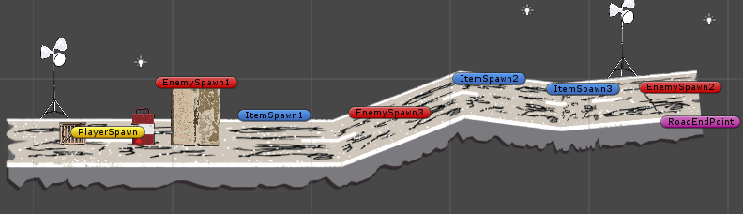

First start off with a prebuilt road section prefab. As you can see above, level details will be prebuilt for each section. So you can design the sections the way you want, but the generator will select sections randomly. Also as you can see in red/blue are enemy spawn points. These are reference points for the generator to randomly place enemies and items. These can be customized and limited as described below:

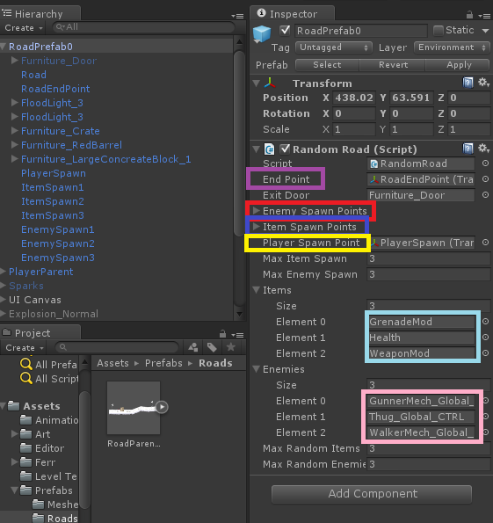There are few things to point out. You will notice in the hierarchy on the left that the Furniture_Door prop is “greyed-out”. This is because it should be placed on every random section but it is disabled until the generator places the last road section. So when you place the door make sure it’s disabled.

The end point is the purple point at the end of the road. It is to tell the generator where to start the next section.

The Player Spawn point is only generated on the first section but you need to place one on every section you build.

The items/enemies list allows you to add or remove different items/enemies to the generated road. The Enemy/Item Spawn points are just lists that hold the spawn points. The max Item/enemy spawn allows you to limit how many of each spawn in the section. The Max Random Items/Enemies allows you to limit the maximum type of each that spawn.

It’s a lot to remember, the best approach would be to copy the prefab and just replace the scenery and move the points around to fit the section you build.

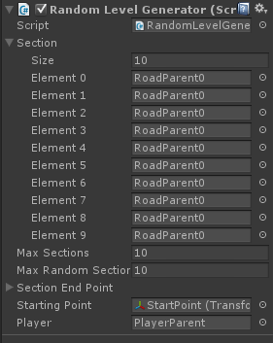Next is the generator itself. This script will be placed in each level. You will assign the different random sections you want generating to the Section list on the left.

MaxSections is the maximum number of sections to generate for the level.

MaxRandomSelection is the maximum type of sections to generate for the level.

Section End Point is handled by the Random Road Script above.

Starting Point is where you want the level to start generating.